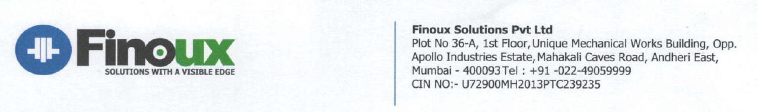

**Letter of Authorization**

I Mr. / Ms. Saifali Salim Mavani hereby authorize Finoux Solutions Pvt. Ltd. To verify all the information provided by me.

I authorize Finoux Solutions Pvt. Ltd. and its third party vendor to conduct all the required reference check who may have information relevant to this enquiry to disclose it to or its representative.

In case Organization finds any information contrary to that provided by me, I accept their decision to withdraw the job offer made to me. The job offer would thereby stand null and void.

Name: Saifali Salim Mavai

Date: 02/09/2022

Signature: 